Summary of notes from Topic 4 (Structure/Structure Change) discussion group led by Chris Fogarty

- Storm size can be detected better with satellite imagery of the modern era and thus we should be able to better communicate threat based on size, and less focus on ‘Vmax’ since that is basically a ‘point’ while size/ACE can better reflect the overall impact threat.

- Establish an augmented scale or some sort of an international standard ‘impact scale’ in order to compare globally. (still maintain existing categorization however – it would take many years to educate users of a new scale)

- More recon studies focussing on storm structure are needed so we can compare between basins – better understand how basins differ so we can understand why

- Sometimes when the TC makes landfall there can be an extreme convective burst in the remnant eye. It usually happens over rugged terrain but only for some events – it would be beneficial to understand when in is likely to occur because the rainfall can be extreme 100+ mm/hr .

- Need to expand upon hazard maps showing track, wind swath, rain swath, etc – complete picture in one graphic – need to explore ways to make it optimal (not too complicated but effective) One example below:

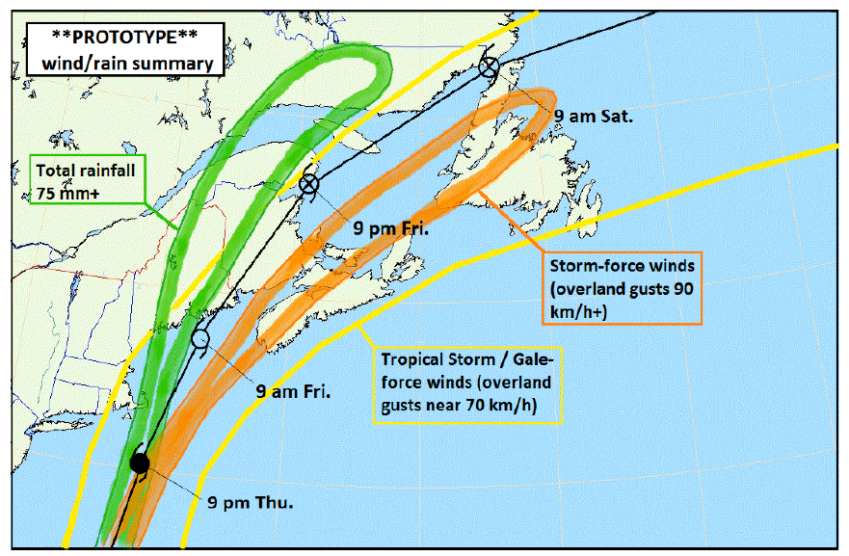

- Boundary layer: wind streaks associated with boundary layer rolls are important but do not always occur. The scale of the features is present on radar but we do not have a lot of high-resolution observations of the extent to which the winds vary over the distance between the bands. High-resolution wind tower array could be deployed to study them and correlate with damage. Some studies in the US but what about other countries/regions? Terrain-dependence?

- It would be good to see more study on the energy “budget” of TCs undergoing eyewall replacement cycles. If we can quantify the ACE, for example, before and after these processes, then we could better communicate the threats. There is often great confusion when people see the category of a storm drop from, say, 4 to 2, then the meteorologist has to convince that the storm is still very large and still very dangerous (Ike 2008 is great example)

- It was shown that frequency of ERCs in TCs over the southern Hemisphere is much less than northern – why is that the case? Is that really the case or is it an observation deficiency?

